Web Engineering
Lab Task 1
Question 1:
On your page, include some or all of the following information:
- On your page there must be at least two hyper-links.
- Address of your e-mail (as hyperlink).
- The link of the web page of web programming course.

Demo Web Page:
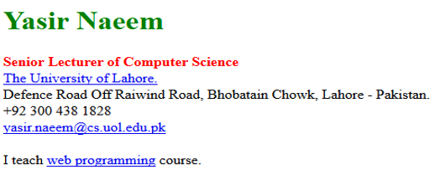

Question 2:

- Design & Create your own CV using multiple Html pages
  - Use HTML language tags for layout
  - Each page must be linked with the Home page
  - Your CV must be divided into pages
    - Home (contain all headings as hyperlinks)
    - Personal Information
    - Academics
    - Experience
    - Skills
    - Hobbies
    - Social Media (Platforms links)

